Chemistry – Class X

Ch-1: CHEMICAL REACTIONS AND EQUATION

PHYSICAL CHANGES: The changes in which only the physical state of a substance changes but the chemical composition of the substance remains the same are known as physical changes.
Example: melting of ice, butter, wax, sublimation, evaporation etc.

CHEMICAL CHANGES: The changes which are accompanied by change in chemical composition of the substances are known as chemical changes.
Example: Rusting of iron, curding of milk, burning of fuel.

CHARACTERISTICS OF CHEMICAL CHANGES:
- Change in colour iv. Formation of precipitate
- Change in state v. Non reversible: permanent
- Evolution of gas vi. Change in temperature

*Write two examples of each of the above based on your regular observations in the surroundings.

CHEMICAL REACTION: All the chemical changes are chemical reactions. It represents the change in the species taking part in the reaction in to new species.

CHEMICAL EQUATION: The short hand representation of chemical reaction is known as chemical equation.
A chemical equation links together the substances which react with the new substances that are formed.
- Reactants: The substances which take part in the reaction are known as reactants.
- Products: The substances which are formed during the chemicals reaction are known as products.
Chemical equations are two types:
- Word Equation
- Symbol Equation

WORD EQUATION: A word equation links together the names of the reactants with those of the products.
Example: Magnesium + Oxygen Magnesium Oxide
Zinc + Hydrogen Chloride Zinc Chloride + Hydrogen Gas

- WRITING WORD EQUATION:
- The reactants are written on the left hand side of the reaction with a plus (+) sign in between.
- The products are written on the right hand side of the reaction with a plus (+) sign in between.
- An arrow () sign separates the reactants from the products.
- The direction of arrow head points towards the products.

SYMBOL EQUATION: It is the representation of the chemical reaction in terms of symbols and chemical formulas of the substances involved.
Mg + O₂ MgO
Zn + HCl ZnCl₂ + H₂

UNBALANCED CHEMICAL EQUATION / SKELETAL EQUATION:
- The equations in which the number of atoms on the reactant side is not equal to the number of atoms on the products sides are called Unbalanced Chemical Equation.
- The equations in which only the reactants and products are indicated are known as skeletal equation.

BALANCED CHEMICAL EQUATION: The chemical equation in which number of atoms on the reactant side is equal to the number of atoms on the product side is known as balanced chemical equation.
2Mg + O₂ 2MgO

NEED TO BALANCE A CHEMICAL EQUATION: The reactions should be balanced so that they can follow the “LAW OF CONSERVATION OF MASS”.

BALANCING THE CHEMICAL EQUATION:
- Enclose the reactants and products into rectangles.
- Tabulate the atoms involved in the reaction into reactant side and product side.
- Equalize both the tables by suitably multiplying with the least possible number.

Mg + O₂ MgO

Element | Reactant | Product
Mg | 1 | 1
O | 2 | 1*2

2Mg + O₂ 2MgO
Element | Reactant | Product
Mg | 1*2 | 2
O | 2 | 2

2Mg + O₂ 2MgO
Element | Reactant | Product
Mg | 2 | 2
O | 2 | 2

Q. Balance the following reactions:
a) Mg + HCl MgCl₂ + H₂
b) HgO Hg + O₂
c) KBr + BaI₂ KI + BaBr₂
d) H₂S + SO₂ S + H₂O
e) CH₄ + O₂ CO₂ + H₂O
f) Na + H₂O NaOH + H₂
g) CaO + H₂O Ca(OH)₂ + heat
h) Fe + H₂O Fe₃O₄ + H₂
i) Pb(NO₃)₂ + KI PbI₂ + KNO₃
j) Cu + AgNO₃ Cu(NO₃)₂ + Ag
k) BaCl₂ + Al₂(SO₄)₃ BaSO₄ + AlCl₃
l) CuSO₄ + KI Cu₂I₂ + K₂SO₄ + I₂
m) CaCO₃ CaO + CO₂
n) MgCO₃ MgO + CO₂
o) N₂ + H₂ NH₃

INFORMATION INFERRED THROUGH A CHEMICAL EQUATION:
- The reactants and products are known.
- The amount of reactants required during the reaction and the products formed are known.
- The states of substances involved in the reaction are known.
(s) solid, (l) liquid, (g) gas, (m) molten, (aq) aqueous, (↑) gas(product), (↓) precipitate(product).
*What is the difference between (l), (m) and (aq)?

4. Reaction conditions are known. These conditions are mentioned on the arrows. The reaction conditions include temperature, pressure, catalyst.
Catalyst: The substances which increases the rate of reaction but do not participate as a reactant.
Example:
N₂ (g) + 3H₂ (g) $\underset{→}{500℃, 200 atm, Fe catalyst }$ 2NH₃ (g)
6CO₂ (g) + 6H₂O (l) $\underset{→}{sunlight, chlorophyll}$ C₆H₁₂O₆ (aq) +6O₂

TYPES OF CHEMICAL REACTION: There are basically 4 types of chemical reactions which are:
- COMBINATION REACTION: The reactions in which two or more reactants combine to form a single product is known as a combination reaction.
A +B +C D
Combination reactions are mostly exothermic in nature.
Example: H₂ +N₂ NH₃; C + O₂ CO₂;
2Mg + O₂ 2MgO; CaO +H₂O Ca(OH)₂

- DECOMPOSITION REACTION: The reactions in which a single substance break down into two or more products is known as a decomposition reaction.
A B + C + D
Decomposition reactions are mostly endothermic in nature.
Various decomposition reactions are:
- THERMAL DECOMPOSITION: Decomposition reaction taking place in presence of heat.
2FeSO₄ (s) $\underset{→}{∆}$ Fe₂O₃ (s) +SO₂ (g) + SO₃ (g)
Dirty white Brown
2Pb(NO₃)₂ (s) $\underset{→}{∆}$ 2PbO (s) + 4NO₂ (g) +O₂ (g)
White Red fumes

- ELECTROLYTIC DECOMPOSITION: Decomposition reaction taking place in the presence of electricity (also known as electrolysis).
2H₂O (l) $\underset{→}{Electrolysis}$ 2H₂ (g) + O₂ (g) [double H₂ than O₂]

- PHOTOLYTIC DECOMPOSITION: Decomposition reaction taking place in presence of light (also known as photolysis).
2AgCl (s) $\underset{→}{hv}$ 2Ag(s) + Cl₂ (g) [Both reactions are used in
2AgBr (s) $\underset{→}{hv}$ 2Ag(s) + Br₂ (g) between photography]

- DISPLACEMENT REACTION: The reaction in which a more reactive metal replaces a less reactive metal from its salt solution.
M_{A} (s) + M_{B} Salt (aq) M_{A} Salt (aq) + M_{B}↓
M_{A}>>M_{B}
Reactivity Series:
K > Na > Ca > Mg > Al > Zn > Fe > Pb > [H] > Cu > Ag > Au > Pt

*Fe (s) +CuSO₄ (aq) Cu (s) + FeSO₄ (aq)
Blue Brown Green

*Cu (s) + 2AgNO₃ (aq) Cu(NO₃)₂ (aq) + 2Ag (s)
Silver deposit
- DOUBLE DISPLACEMENT REACTION: The reaction in which exchange of ions in between the reactants take place, the reaction is known as double displacement reaction.
Example:
BaCl₂ (aq) + Na₂SO₄ (aq) BaSO₄ (s) +2NaCl (aq)
White
AgNO₃ (aq) + NaCl (aq) AgCl (s) + NaNO₃ (aq)
White
Pb(NO₃)₂ (aq) + Na₂SO₄ (aq) PbSO₄ (s) + 2NaNO₃ (aq)
White
KI (aq) + Pb(NO₃)₂ (aq) PbI₂ (l) + KNO₃ (aq)
Yellow

*In all Double displacement reactions, one of the products is a solid called a precipitate hence these reactions are also known as Precipitation \Reaction.

Calcium Oxide Cycle

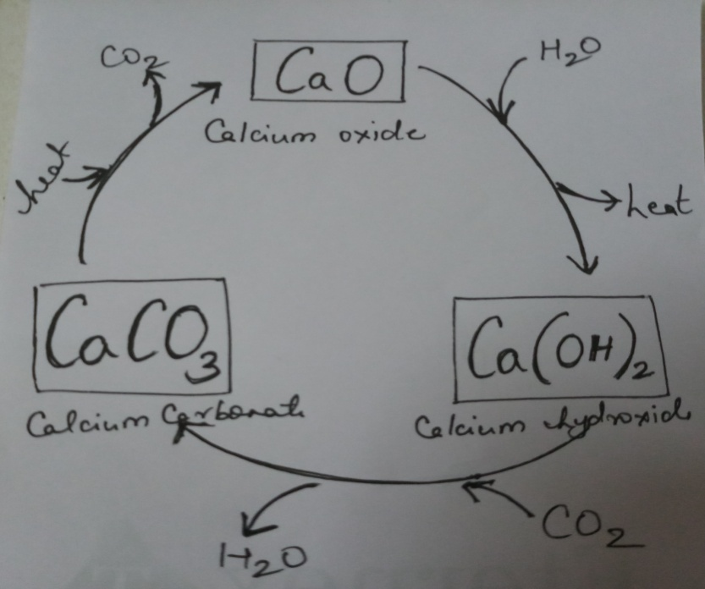
CaO : Calcium Oxide (Quick Lime)

Ca(OH)₂ : Calcium Hydroxide (Slaked
Lime/Lime water)

CaCO₃ : Calcium Carbonate
(Limestone: Chalk/Marble/Egg shell/Sea shells)

*The reaction of CO₂ with lime water is used as a test for CO₂ in the laboratory. Milkiness appears in limewater due to formation of Calcium carbonate confirming the presence of CO₂.

REDOX REACTIONS:

OXIDATION REACTION: The reactions in which oxygen is added or hydrogen gets removed or loss of electrons takes place.
Mg + O₂ MgO
REDUCTION REACTION: The reactions in which oxygen is removed, hydrogen gets added or gaining of electrons take place.
N₂ + H₂ NH₃
REDOX REACTION: The reactions in which oxidation and reduction takes place simultaneously.
Example:

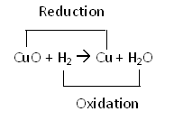;

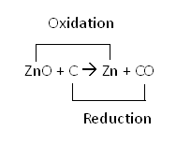;

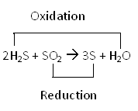 ;

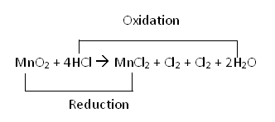

;
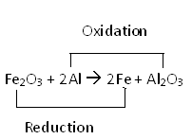

*Identify Oxidation and reduction parts in all of the above reactions.

- OXIDISING AGENT: The substance which itself gets reduced and oxidized the other substance, is known as oxidising agent.
- REDUCING AGENT: The substance which itself gets oxidised and reduces the other substance, is known as reducing agent.

EFFECT OF OXIDATION:
- CORROSION: The chemical process of slow eating up of the surfaces of certain metals when kept in open for a long time.
Example: rusting of iron (Fe₂O₃.xH₂O), blackening of silver (Ag₂S), green layer on copper (CuCO₃).
Prevention: painting, oiling/ greasing, galvanization, chromplating.
- RANCIDITY: The slow oxidation of oils and fats present in food materials resulting in some bad smelling compounds.
Prevention:
- Packing food in air tight containers.
- Refrigeration
- Packets of chips are flushed in with inert gas (N₂).
Antioxidants: The substances which prevent oxidation are known as antioxidants.

Assignment

Q1. Give an Example of Thermal decomposition reaction?
Q2. Write a combination reaction used in white washing.
Q3. Why Photographic film should not be exposed to light?
Q4. What are Displacement Reactions?
Q5. Complete the reaction: Mg + ZnSO4 _____ + _____
Q6. What are double displacement reactions?
Q7. Why do we apply paints on Iron articles?
Q8. Define Corrosion.
Q9. What does the term Redox mean?
Q10. Define Precipitation Reaction.
Q11. What is the colour of Copper Sulphate crystals?
Q12. What are exothermic reactions?
Q13. What is a precipitate?
Q14. What does (m) signify?
Q15. When is down arrow used in a chemical reaction?
Q16. What is the color of the precipitate formed when we mix the solution of lead(II) nitrate with
Potassium Iodide. Name the compound precipitated. Write the balanced chemical Equation.
Q17. What is the difference between Combination and Decomposition Reaction? Write an equation of
each type.
Q18. What do you understand by Exothermic & Endothermic reactions? Give Examples.
Q19. Write one equation each for the decomposition reaction where energy is supplied in the form of
a) heat b) light c) electricity.
Q20. A shiny brown colored element ‘X’ on heating in air becomes black in color. Name the element ‘X’
and the black colored compound formed.
Q21. Write a short note on corrosion.
Q22. Explain: Oxidation and reduction are opposite to each other.
Q23. Explain: Combination and decomposition are opposite to each other.
Q24. Identify the type of chemical reaction taking place in each of the following–
- Barium chloride solution is mixed with copper sulphate solution and a white precipitate is formed.
- On heating copper powder in air in a china dish, the surface of the copper powder turns black.
Q25. Why should magnesium wire be cleaned before burning in air?
Q26. (i) Explain the following terms
(a)Oxidation (b) Rancidity
(ii) Give reason for the following
(a)Respiration is considered exothermic reaction
(b)Oil and fat containing food items are flushed in with nitrogen
(iii) How will you show that silver is chemically less reactive than copper
Q27.Name the oxidizing agent, reducing agent, oxidation & reduction in the following redox reaction
- ZnO + C Zn + CO
- MgO + C Mg + CO
- Zn + CuSO₄ ZnSO₄ + Cu
- H₂ + CuO Cu + H₂O
- 4NH₃ + 5O₂ 4NO + 6H₂O
Q28.With the help of an activity descried double displacement reaction. Why are double displacement reaction not redox?
Q29. What do you mean by a Chemical Change?
Q30. What do you mean by a Physical Change?
Q31. Define Chemical Reaction.
Q32. Give the significance of arrow sign in a Chemical Equation.
Q33. Give an example of Chemical Change.
Q34. What does (s) in a chemical reaction signify?
Q35. What is the difference between (m), (l) and (aq) in a chemical equation.
Q36. Magnesium ribbon should be cleaned before burning. Why?
Q37. Complete the missing components in the following equation:
CaCO₃ (s) CaO (s) + CO₂ (y)
Q38. What is the principle used in balancing the chemical equation?
Q39. Write Chemical Equation for the following:
Copper Sulphate on treatment with Potassium Iodide precipitates Cuprous Iodide, liberates iodine gas and also forms potassium Sulphate
Q40. Give the characteristics of Chemical reactions.
Q41. What information is furnished by a Chemical reaction?
Q42. What is the difference between skeletal & Balanced Chemical Equation?
Q43. Which of the following processes involves a chemical Change?
- Liquefaction of air b) Heating Aluminum wire in the presence of air.

